## Properties of the Road Tool - Distance Markers

This section allows you to activate distance markers on the road. On the image below, you can see the distance markers have been set to **True** and are visible on the road, also font color changed to black.

**To activate Distance Markers on a road:**

* Select the road.
* On the **Distance Markers** section of the properties palette click **False** in the **Show** section to change it to **True**.
* 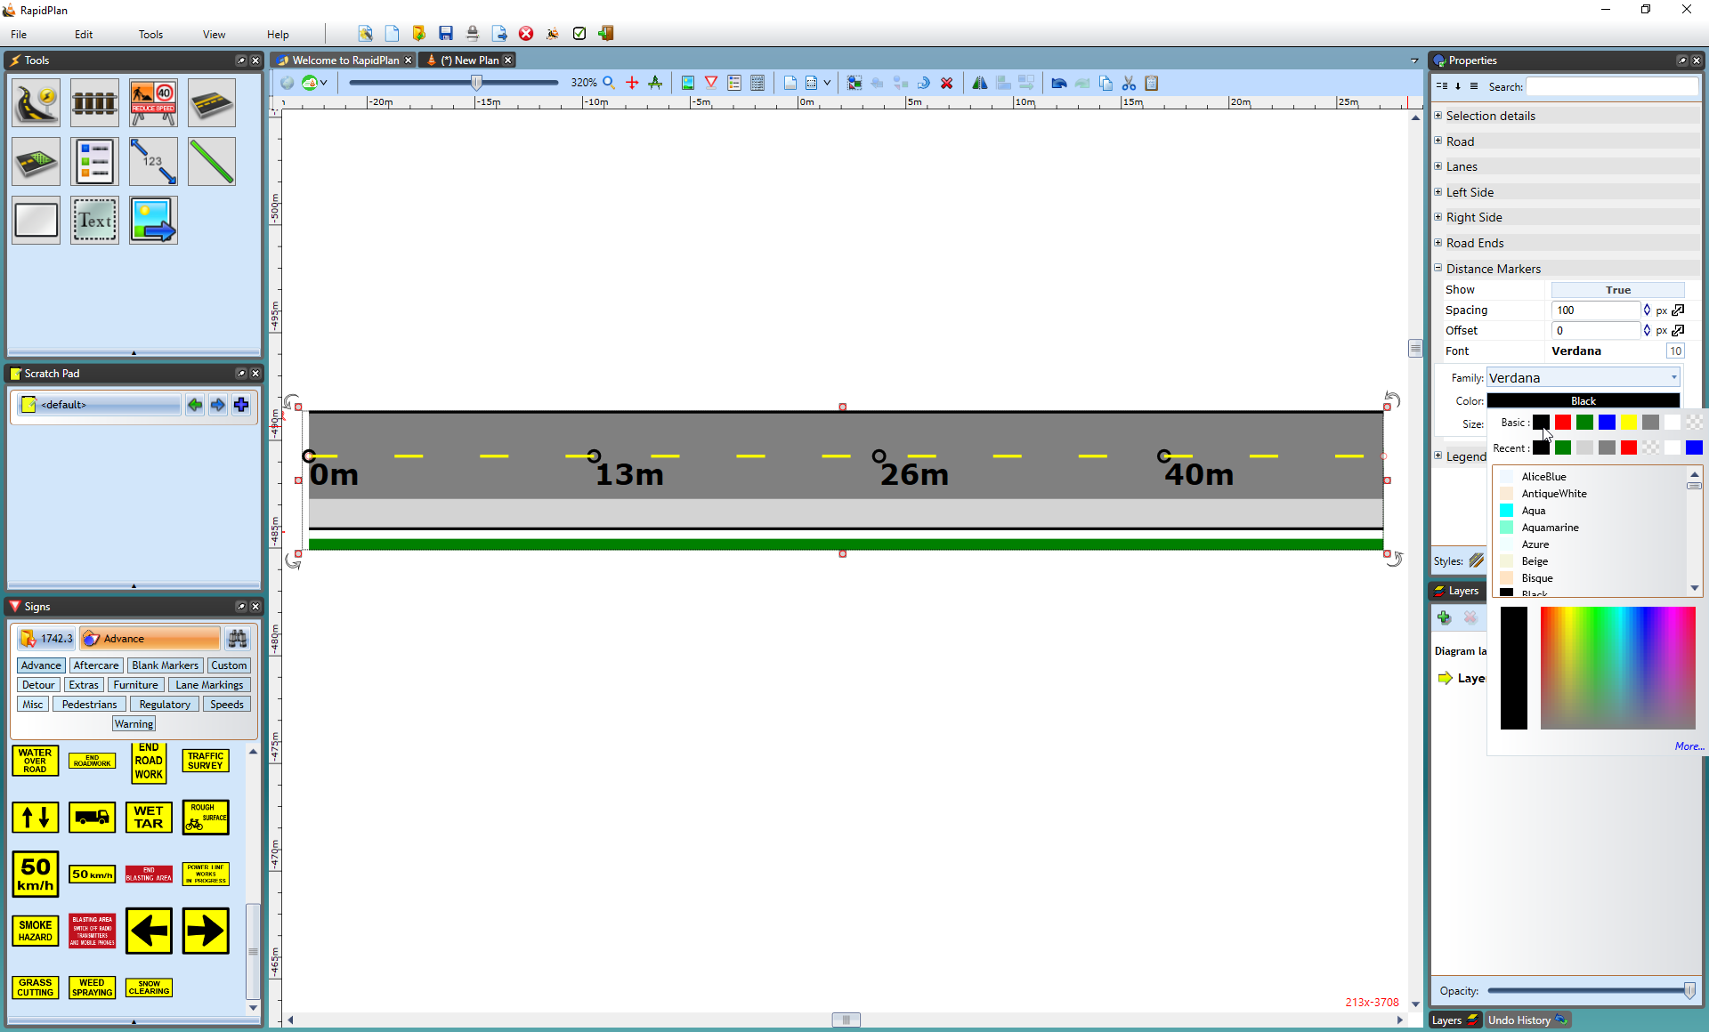
* Activated_Distance_Markers_on_a_road